**Practical No 03**

**Title –** Write a program to recognize a document is positive or negative based on polarity words using suitable classification method

**DataSet –**

**@relation employee**

**@attribute empid numeric**

**@attribute name {soham, sam, vrunda, vikrant, vishal,ram,krushna}**

**@attribute salary numeric**

**@attribute gender {male, female}**

**@attribute contactno numeric**

**@attribute Yr_of_exp numeric**

**@attribute Designation {Trainer,Devloper,Tester,Team_Lead,Fresher}**

**@attribute email {sohmya123@gmail.com,sam32@gmail.com,vrunda123@gmail.com,vikrant123@gmail.com,vishal23@gmail.com,ram123@gmail.com,krushna123@gmail.com}**

**@data**

**101, soham, 10000, male, 94568654,2,Trainer,sohmya123@gmail.com**

**102, sam, 10000, male, 80256895,4,Devloper,sam32@gmail.com**

**103, vrunda, 12000, female, 90258965,7,Team_Lead,vrunda123@gmail.com**

**104, vikrant, 13000, male, 45895645,3,Tester,vikrant123@gmail.com**

**105, soham, 12000, male, 96231485,2,Trainer,sohmya123@gmail.com**

**102, sam, 10000, male, 80256895,4,Devloper,sam32@gmail.com**

**106, vishal, 10000, male, 89562341,7,Team_Lead,vishal23@gmail.com**

**101, soham, 10000, male, 94568654,2,Trainer,sohmya123@gmail.com**

**102, sam, 10000, male, 80256895,4,Devloper,sam32@gmail.com**

**103, vrunda, 12000, female, 90258965,7,Team_Lead,vrunda123@gmail.com**

**104, vikrant, 13000, male, 45895645,3,Tester,vikrant123@gmail.com**

**105, soham, 12000, male, 96231485,2,Trainer,sohmya123@gmail.com**

**102, sam, 10000,male, 80256895,4,Devloper,sam32@gmail.com**

**106, vishal, 10000, male, 89562341,7,Team_Lead,vishal23@gmail.com**

**104, vikrant, 13000, male, 45895645,3,Tester,vikrant123@gmail.com**

**102, sam, 10000, male, 80256895,4,Devloper,sam32@gmail.com**

**107, ram, 17000, male, 54784895,2,Trainer,ram123@gmail.com**

**108, krushna, 19000, male, 87256895,2,Devloper,krushna123@gmail.com**

* 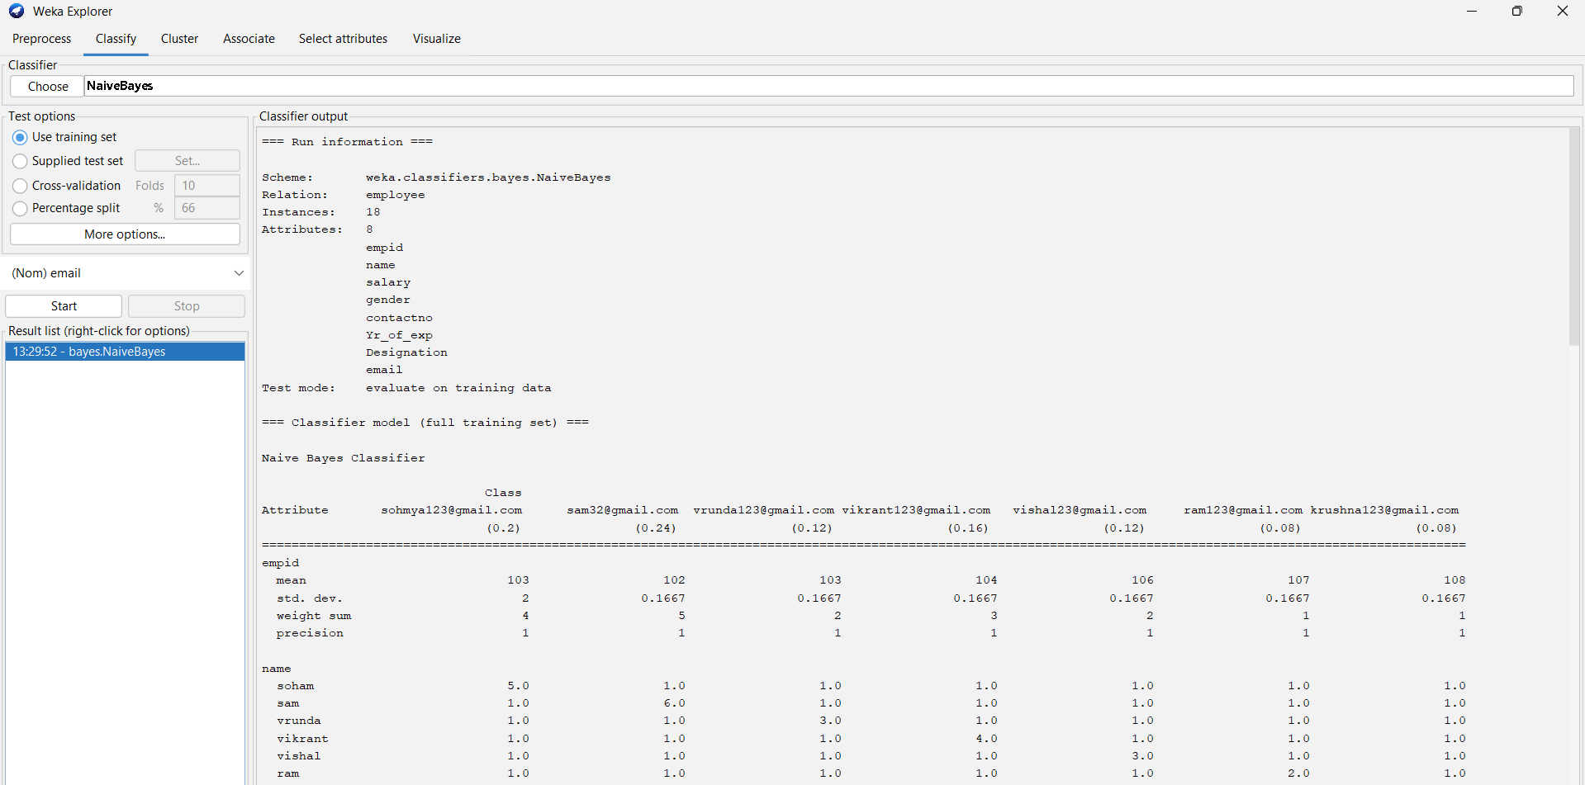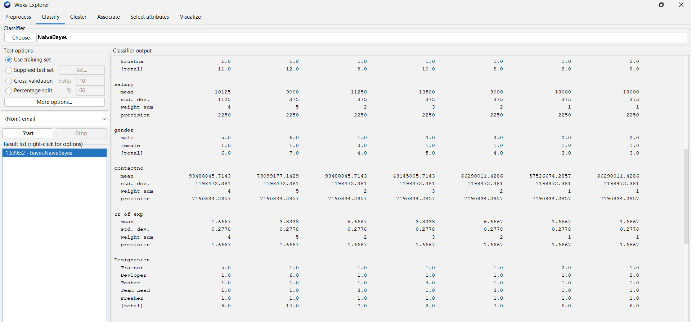**Apply Naïve Bayes theorem use Training dataset -**

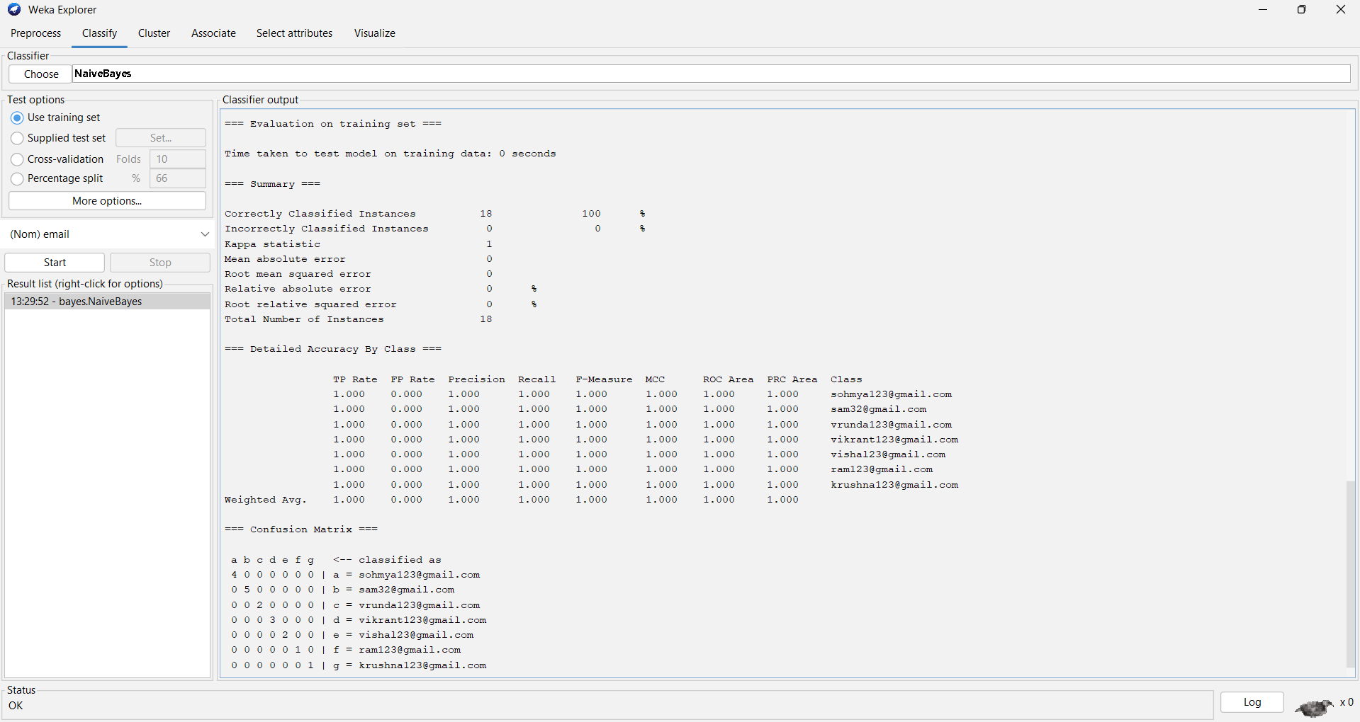

* **Supplied Test Set –**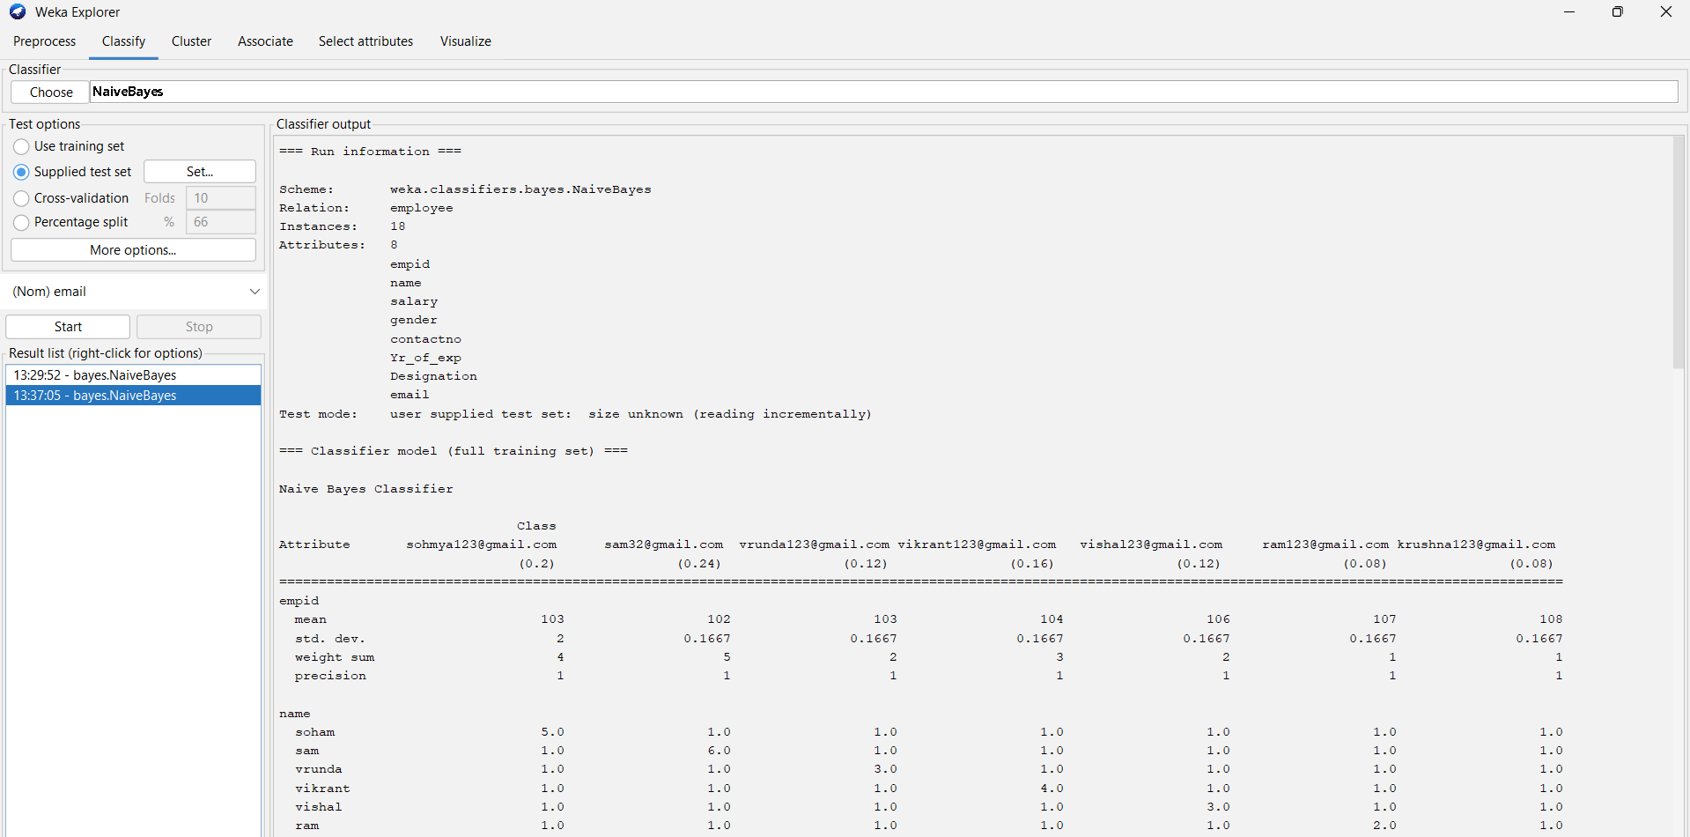

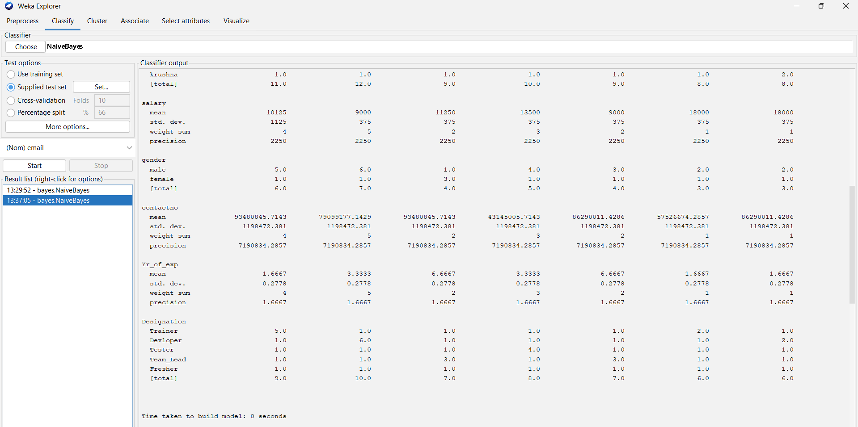

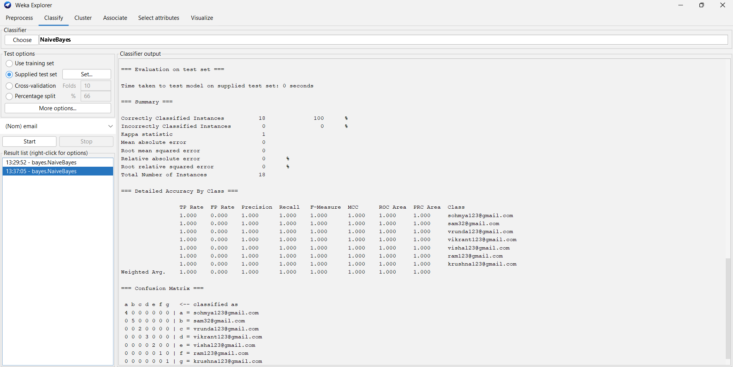

* 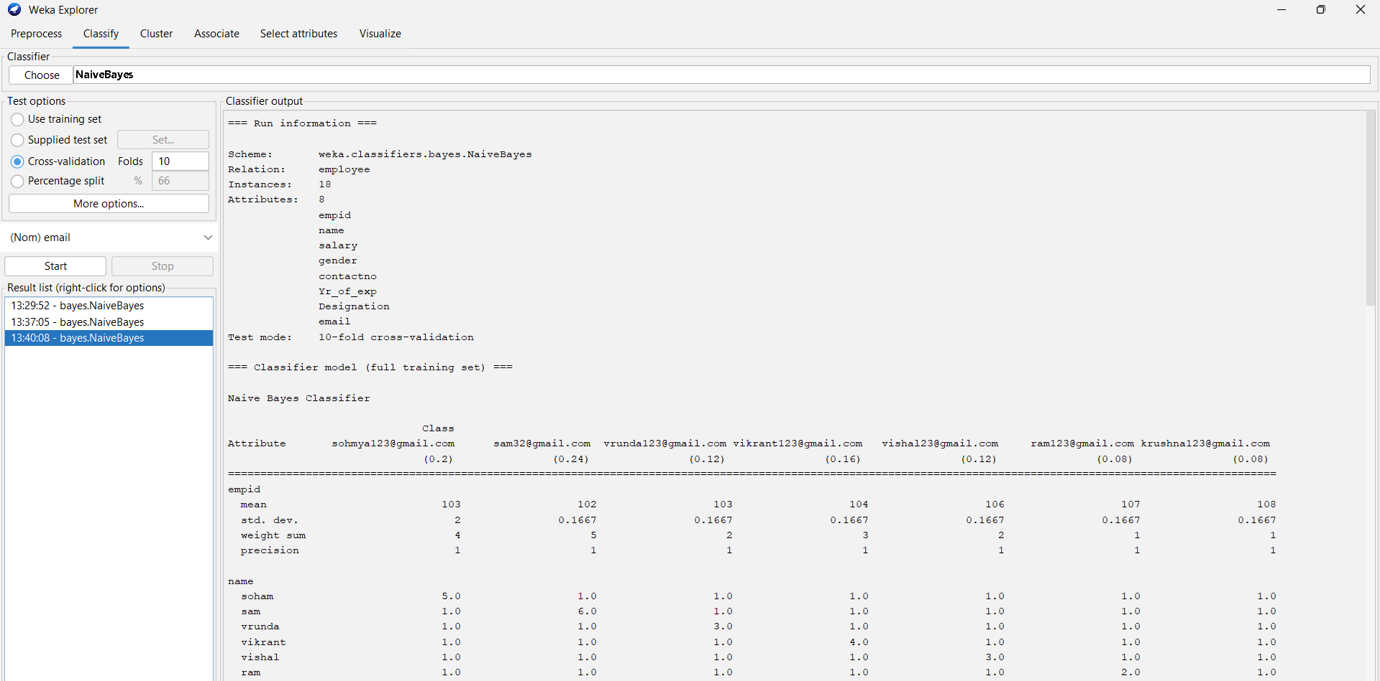10-fold Cross Validation –

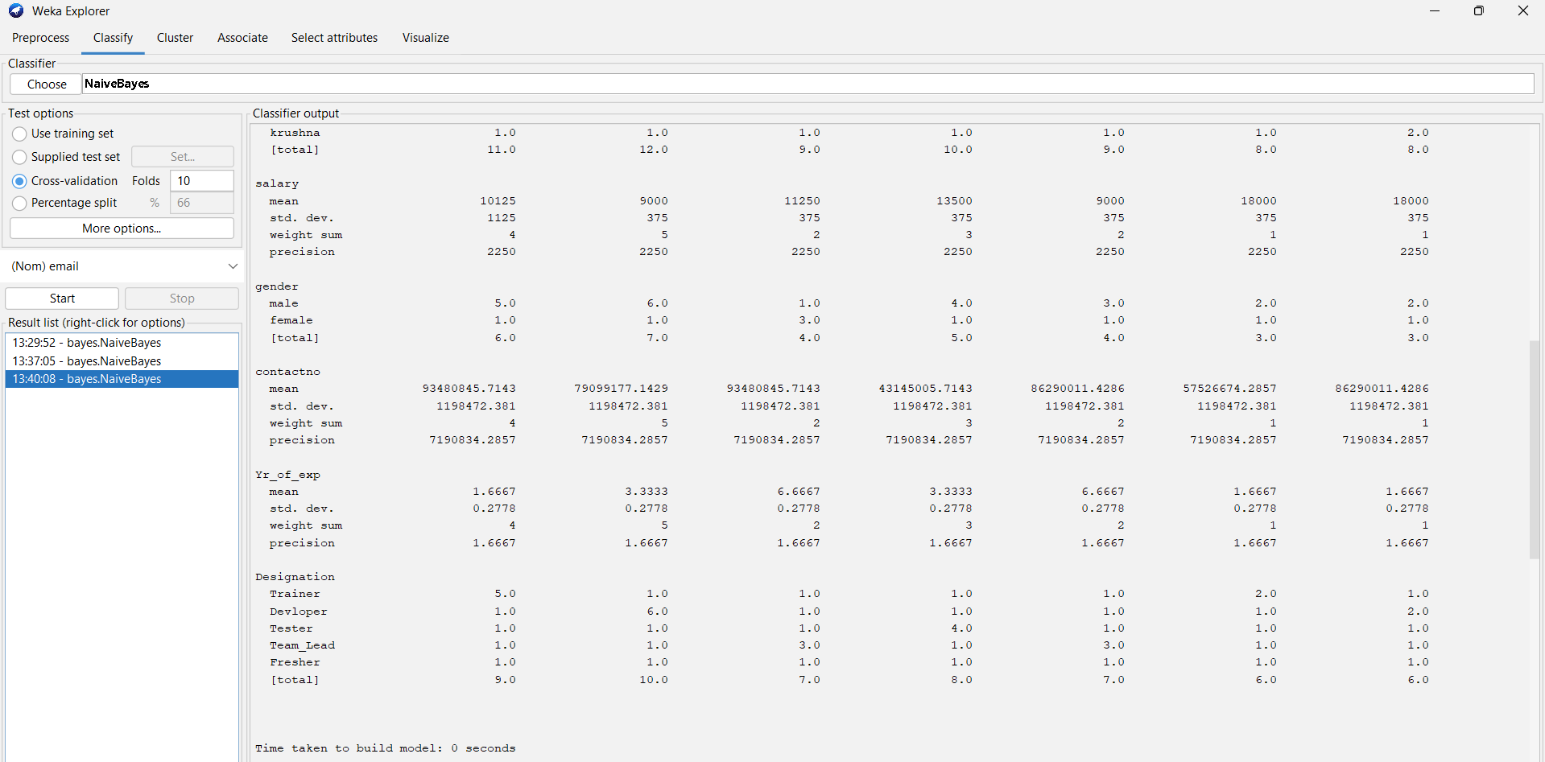

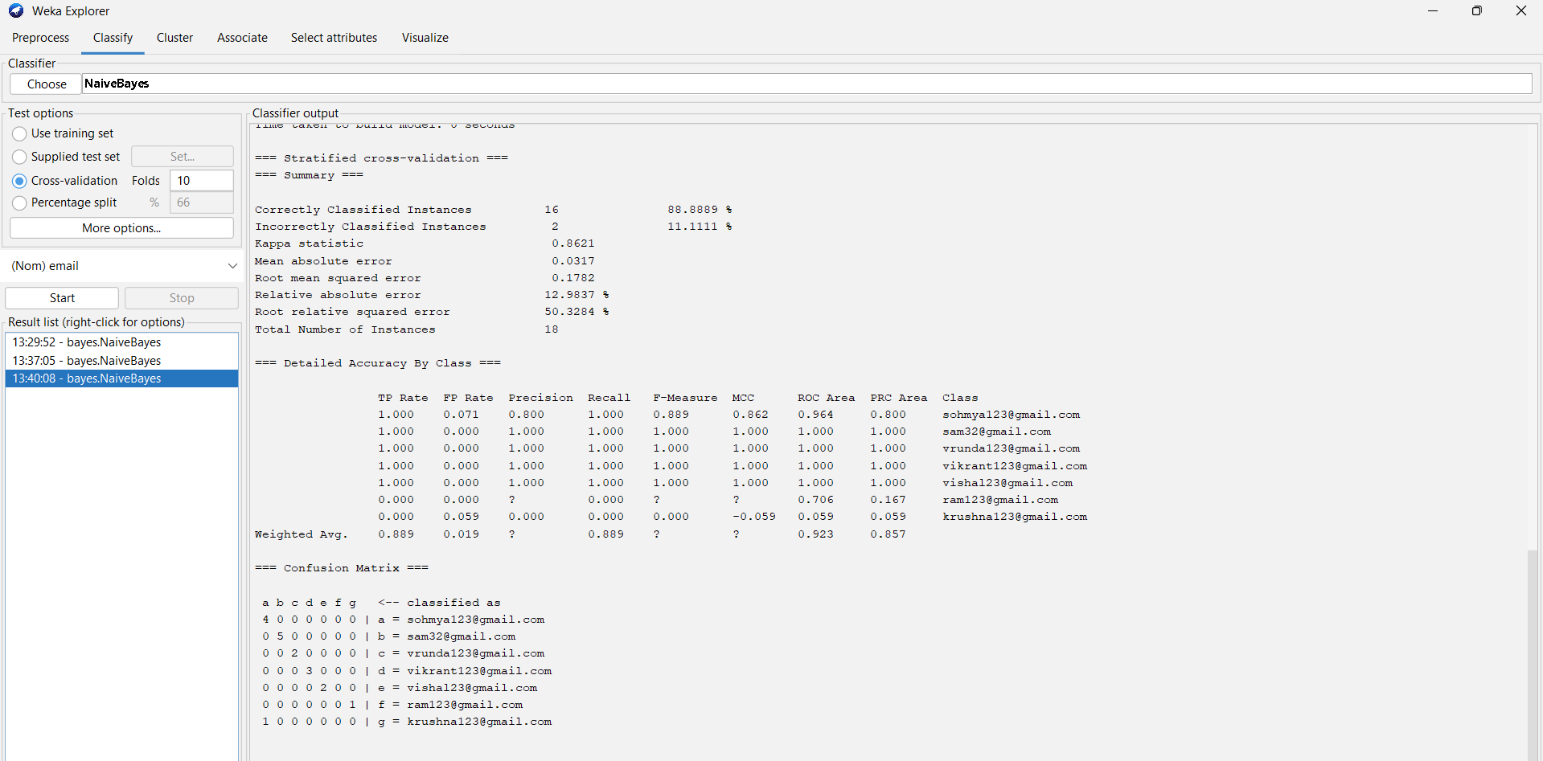

* Percentage split = Test mode: split 66.0% train, remainder test

